Build Tic Tac Toe Game — LLD + Code — Complete Notes

Introduction
Designing the low-level design (LLD) of Tic Tac Toe — a common interview question alongside Snake and Ladders. Simple game, but tests design thinking around extensibility, patterns, and clean separation of concerns.

Functional Requirements
# | Requirement
1 | Board size should be scalable — support 3×3, 4×4, 5×5, or n×n (not hardcoded to 3×3)
2 | Standard game rules should be extensible — support custom rules in the future
3 | On-app notifications — when a player makes a move or wins, notifications should appear on the app for both players
On-app notification definition: Like online chess or Ludo — when P1 makes a move, both P1 and P2 see an in-app alert ("P1 played X at (0,0)" or "P1 wins"). Not email/SMS/push — it's in-app.
Note on standard rules: Default win condition — 3 in a row (horizontal, vertical, or diagonal) for 3×3 board. The design should allow custom rules later (e.g., "no diagonal wins", "need 4 in a diagonal").

Design Approach — Top-Down
For games, prefer top-down: design the big classes first (Game), then decompose into smaller pieces (Board, Rules, Players). This makes later decomposition easier.
Order of design:
- Game (main orchestrator)
- Board (from Game)
- Symbol (from Board)
- Rule / RuleStrategy (from Game)
- StandardRule (concrete strategy)
- Player (from Game)
- IObserver + ConsoleNotifier (for notifications)
- GameFactory + GameType (factory for game creation)

Class-by-Class Design

1. Game Class (Orchestrator / Main)
The largest, most complex class — coordinates all other components.

Fields
Field | Type | Purpose
board | Board | The playing board
players | Deque<Player> | Players in turn order (double-ended queue)
rules | Rule | The rule strategy for this game
observers | List<IObserver> | Notification observers
gameOver | boolean | Whether the game has ended

Why Deque (not List) for Players
Simple approach: A boolean flag isPlayer1Move toggling between two players.
- Works only for 2 fixed players
Scalable approach: Deque (double-ended queue) — supports n players
- Players initially enqueued (P1, P2)
- On a turn: currentPlayer = players.pollFirst(), player makes move, then players.addLast(currentPlayer)
- This cycles turns naturally: P1 → P2 → P1 → P2... or P1 → P2 → P3 → P1...
Pattern: Turn rotation via queue rotation — elegant and extensible.

Methods
Method | Purpose
addPlayer(Player) | Add player to Deque
addObserver(IObserver) | Add notification observer
removeObserver(IObserver) | Remove observer (optional)
notifyAll(message) | Broadcast message to all observers
setRule(Rule) | Set rule strategy
play() | Main game loop — orchestrates the entire game

2. Board Class
Single Responsibility Principle: Board only manages its own cells — which symbol is where, which cells are empty. It does NOT know the game rules (who wins, what counts as a win).

Fields
Field | Type | Purpose
grid | List<List<Symbol>> (2D vector) | The n×n grid of symbols
size | int | Board dimension
emptyCell | Symbol | Symbol representing empty cells (avoids null issues)

Why Empty Symbol Instead of Null
- Null causes NullPointerException when we try to access a symbol
- Using a dedicated emptyCell symbol with underscore _ marker avoids null checks everywhere
- Simplifies isCellEmpty and cell access logic

Constructor
java
Board(int size) {
this.size = size;
this.emptyCell = new Symbol('_');
// Initialize grid with emptyCell for all cells
for (i in 0..size) for (j in 0..size)
grid[i][j] = emptyCell;
}

Methods
Method | Purpose
isCellEmpty(row, col) | Check if cell has emptyCell symbol
placeMark(row, col, symbol) | Place symbol at position (validates validity + emptiness)
getCell(row, col) | Return the symbol at row,col
display() | Print the entire board state
getSize(), getEmptyCell() | Getters
Validation in isCellEmpty and placeMark: row must be ≥ 0 and < size; same for col. Out-of-bounds → return false.

3. Symbol Class
Minimal class.

Fields
Field | Type | Purpose
mark | char | The character representing the symbol (e.g., 'X', 'O', '_')

Methods
- getMark() — returns the char
Extensibility note: Can be extended to include display logic (how to render the symbol on screen) — not needed for current scope.
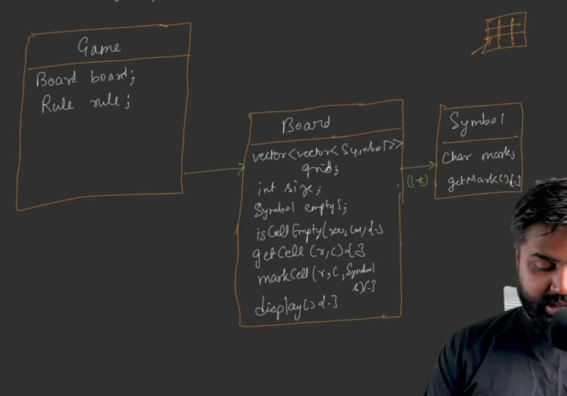

4. Rule Class (Abstract Strategy)
Rule handling is separated from Board to follow SRP and enable extensibility (Strategy Pattern).

Why Strategy Pattern Here
- Standard rules = normal Tic Tac Toe
- Custom rules possible (e.g., "no diagonal wins", "need 4 in a diagonal")
- Making Rule abstract with concrete implementations allows swapping rules per game

Methods (Abstract)
Method | Signature | Purpose
checkWin(Board, Symbol) | Returns boolean | Does this symbol have a winning set on this board?
checkDraw(Board) | Returns boolean | Is the game a draw?
isValidMove(Board, row, col) | Returns boolean | Is this a legal move?

5. StandardRule (Concrete Strategy)
Implements standard Tic Tac Toe rules.
isValidMove(board, row, col):
- Delegates to board.isCellEmpty(row, col)
- Returns true if the cell is empty and within bounds
checkWin(board, symbol):
- Check rows: For each row, if all cells == symbol → return true
- Check columns: For each column, if all cells == symbol → return true
- Check main diagonal: (0,0), (1,1), (2,2)... — if all == symbol → return true
- Check anti-diagonal: (0, n-1), (1, n-2)... — if all == symbol → return true
- If none match → return false
checkDraw(board):
- Iterate every cell; if any cell is empty → return false (moves still possible)
- If all cells filled AND no winner (checked before calling checkDraw) → return true (draw)
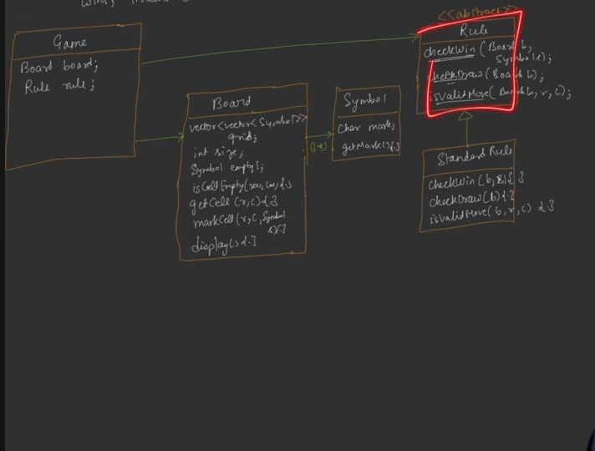

6. Player Class

Fields
Field | Type | Purpose
playerId | String | Unique player identifier
name | String | Player name
symbol | Symbol | Player's symbol (X, O, or custom)
score | int | Cumulative score across games
Extensibility: Player could also be an observer (for direct push notifications), but that complicates the design — skipped for now.

Methods
Method | Purpose
getName(), getSymbol(), getScore() | Getters
incrementScore() | Score++ on win
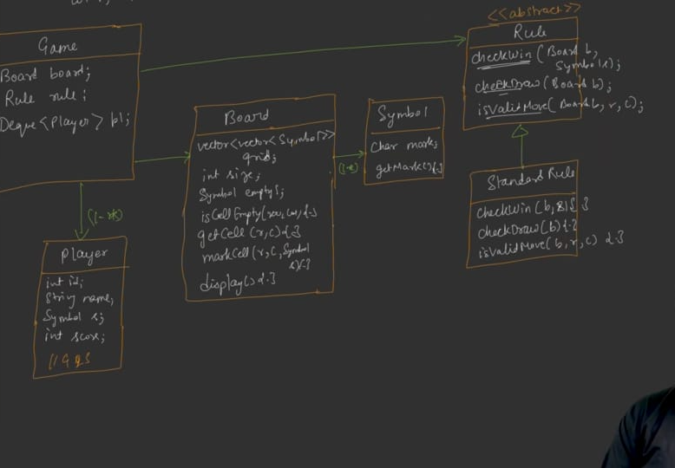

7. Observer Pattern — Notifications

7a. IObserver (Abstract/Interface)
text
IObserver
+ update(message: String)
- Single method update(message) — the Observable calls this on each observer with a message

7b. ConsoleNotifier (Concrete Observer)
- Implements IObserver
- update(message) → prints "Notification: <message>" to console
Why not Player as Observer:
- Player receives notifications via the app, not email/SMS
- In real apps, a notification engine talks to a 3rd party (email/SMS service)
- For in-app: the notifier just displays on the app UI — no external call
- Cleaner to have a dedicated ConsoleNotifier observer
- Later extensible: add EmailNotifier, SMSNotifier, LoggerObserver, etc.

7c. Game as Observable
- Game holds List<IObserver> observers
- addObserver(o) — append to list
- notifyAll(message) — iterate observers, call update(message) on each
- removeObserver(o) — remove from list
Notification triggers:
- Game started
- Player made a move
- Player won
- Game drawn
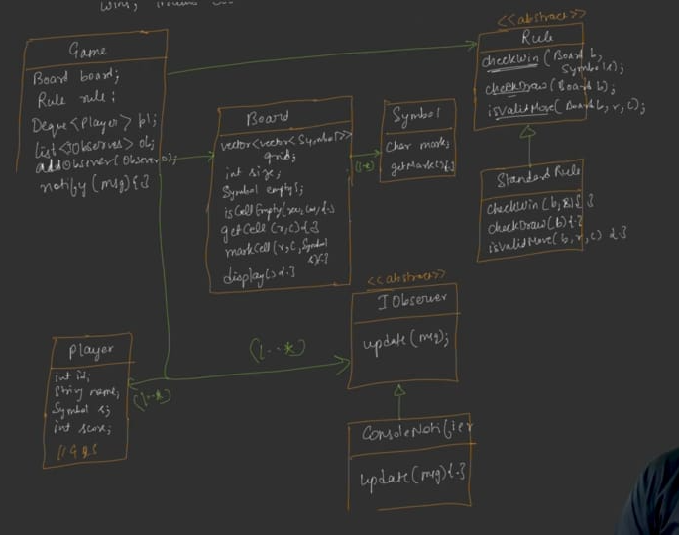

8. GameType Enum + GameFactory

GameType (Enum)
text
STANDARD // only type for now — can extend with CUSTOM later

GameFactory
- Static method: createGame(GameType type, int boardSize) : Game
- If STANDARD → create Game, set new StandardRule() as rule, return
- If unknown type → return null (or default)
Why Factory:
- Impresses interviewers (shows you know when to apply Factory)
- Real-world benefit: centralizes game creation logic
- Easier to add new game types (e.g., custom rule games) later

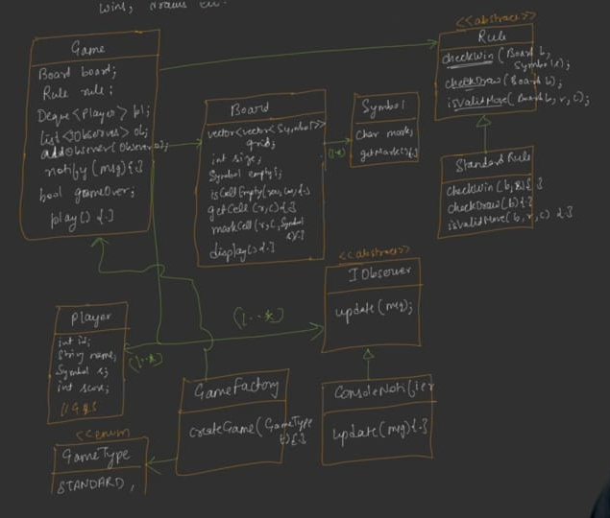

UML Relationships Summary
Relationship | Details
Game has-a Board | Composition (Board's lifetime tied to Game)
Game has-a Rule | Composition (Rule cannot exist without Game — none use it independently)
Game has-a Deque<Player> | 1-to-many
Game has-a List<IObserver> | 1-to-many (Observer pattern)
Board has-a List<List<Symbol>> | 2D grid
Player has-a Symbol | Composition
Rule (abstract) ← StandardRule | Inheritance (Strategy)
IObserver (abstract) ← ConsoleNotifier | Inheritance
GameFactory creates Game | Factory pattern
GameFactory uses GameType | Enum lookup
Composition vs Aggregation decision:
- Game has-a Rule is strong composition — rules don't exist independently of the game
- UML uses filled diamond for this
Note: Deque<Player> — in UML shown as 1..* relationship from Game to Player.

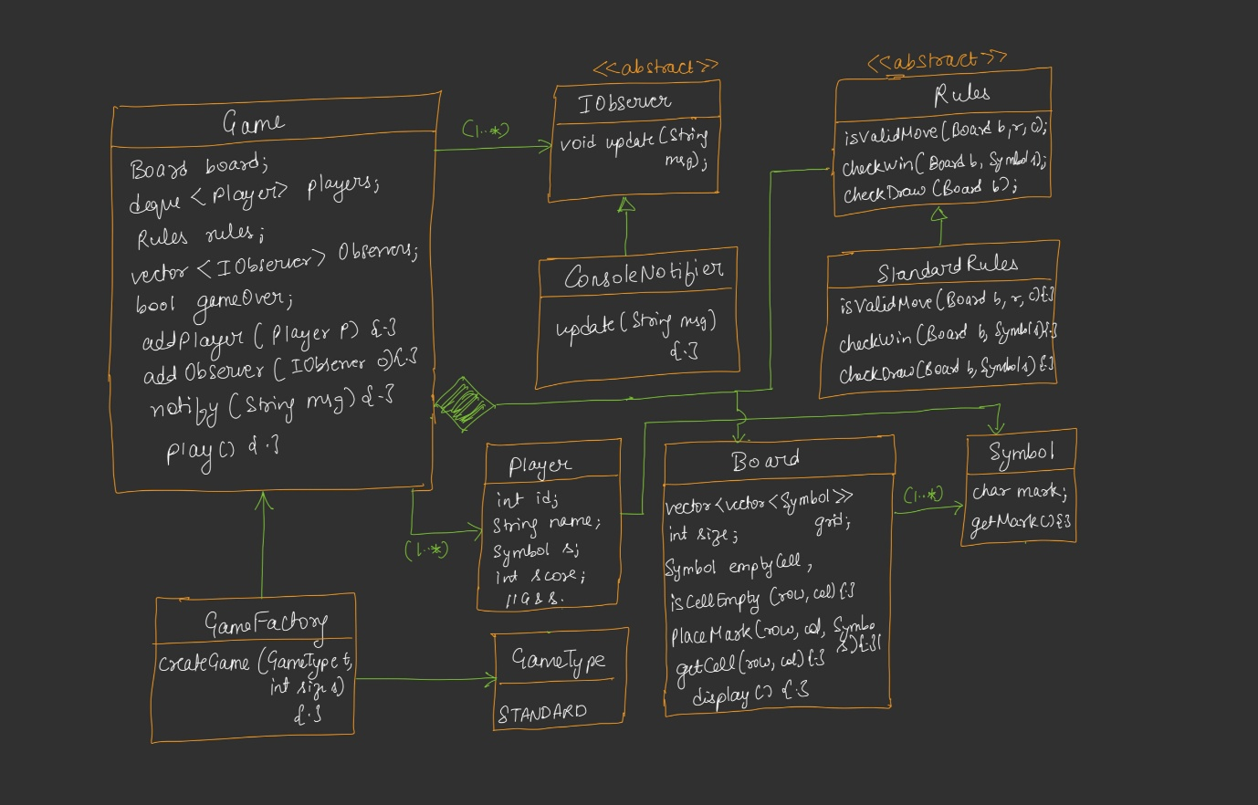

Gameplay Flow (Client ↔ Game.play)
text
Client → Game.play()
│
├─ Validate: at least 2 players required (else print error & exit)
│
├─ notifyAll("Game Started")
│
├─ while (!gameOver):
│ │
│ ├─ currentPlayer = players.pollFirst() // get next player
│ │
│ ├─ Ask input: "row col" for current player
│ │
│ ├─ if (rules.isValidMove(board, row, col)):
│ │ ├─ board.placeMark(row, col, currentPlayer.symbol)
│ │ ├─ notifyAll("Player X played at (row, col)")
│ │ ├─ board.display()
│ │ │
│ │ ├─ if (rules.checkWin(board, currentPlayer.symbol)):
│ │ │ ├─ board.display()
│ │ │ ├─ currentPlayer.incrementScore()
│ │ │ ├─ notifyAll("<PlayerName> wins")
│ │ │ └─ gameOver = true
│ │ │
│ │ ├─ else if (rules.checkDraw(board)):
│ │ │ ├─ board.display()
│ │ │ ├─ notifyAll("It's a draw")
│ │ │ └─ gameOver = true
│ │ │
│ │ └─ else:
│ │ └─ players.addLast(currentPlayer) // requeue for next turn
│ │
│ └─ else:
│ └─ print("Invalid move. Try again.")
│
└─ End loop (gameOver == true)

Sequence Details
- Validation: If fewer than 2 players, exit.
- Notification: Broadcast game start.
- Turn loop:
  - Poll player from front of deque
  - Get input (row, col)
  - Validate move
  - If valid: place mark, notify, display board
  - Check win → if won: display, increment score, notify win, set gameOver
  - Check draw → if draw: display, notify draw, set gameOver
  - If neither win nor draw: requeue player at end
  - If invalid move: print error, loop continues (same player will be re-polled)
- Loop exits when gameOver == true.
Key insight: The requeue mechanism means a failed move leaves the same player to move again — since we re-poll currentPlayer on the next iteration.

Code — Key Highlights

Sample Game Setup (Main Method)
java
int boardSize = userInput(); // e.g., 3
Game game = GameFactory.createGame(GameType.STANDARD, boardSize);

// Add notifier observer
game.addObserver(new ConsoleNotifier());

// Create players
Player p1 = new Player("p1", "Aditya", new Symbol('X'));
Player p2 = new Player("p2", "Harshita", new Symbol('O'));

// Add players
game.addPlayer(p1);
game.addPlayer(p2);

// Start game
game.play();

Console Test Output (Sample)
text
Please enter board size: 3
_ _ _
_ _ _
_ _ _

Aditya's turn (X). Enter row col: 0 0
X _ _
_ _ _
_ _ _

Notification: Harshita played O at (0,2)
X _ O
_ _ _
_ _ _

... (game continues) ...

X X X
O _ O
O _ _
Notification: Aditya wins!

Invalid Move Handling
If the player enters a row/col that is already occupied (or out of bounds):
text
Invalid move. Try again.
The same player remains to move again in the next iteration.

Design Patterns Used
Pattern | Where | Purpose
Strategy | Rule (abstract) + StandardRule (concrete) | Interchangeable rule sets
Observer | IObserver + ConsoleNotifier; Game as Observable | In-app notification broadcast
Factory | GameFactory + GameType | Centralized game creation
Composition | Game owns Board and Rule | Strict ownership
SRP-guided separation | Board separate from Rule; notifier separate from Player | Each class has one reason to change
Design trade-off noted: Game is an orchestrator — it breaks SRP by nature (it delegates to many), but that's inherent to orchestrator/facade patterns.

Key Interview Points
- Scalable board size — n×n via constructor, not hardcoded to 3
- Extensible rules — Strategy pattern means new rules can be added without touching existing code
- Deque for player turns — cyclically rotates players; scales to n players
- Empty symbol instead of null — avoids null-pointer exceptions
- Board doesn't know rules — clean SRP; rule logic in Rule class
- Observer for notifications — decoupled broadcast; easy to add Email/SMS notifiers later
- Game is orchestrator — main loop lives here; everything else is a delegate
- Factory for game creation — professional touch; also helps add custom-rule games later
- Composition over aggregation — Rule and Board truly can't exist without Game
- Board's internal grid is a 2D vector of Symbol — clean abstraction; symbol can be any character

Extensibility Suggestions
- Add custom rules: Create CustomRule extends Rule, override win condition (e.g., "no diagonal wins", "need N in a row")
- Add more observers: EmailNotifier, SMSNotifier, LoggerObserver — all implement IObserver
- Add more game types: Extend GameType enum and GameFactory to support variants
- Multi-player Tic Tac Toe: Rule logic + board size adjustment; deque already supports n players
- Player as observer: If direct per-player push is needed, implement Player implements IObserver — but this creates additional coupling (Player as both observer and observable in some designs)

One-Line Summary per Class
Class | One-line Summary
Game | Orchestrator — owns Board, Rule, Players, Observers; runs the main play() loop
Board | Manages the n×n grid of Symbols; exposes isCellEmpty, placeMark, getCell, display
Symbol | Wraps a single char mark
Rule (abstract) | Strategy interface — checkWin, checkDraw, isValidMove
StandardRule | Standard Tic Tac Toe rule implementation
Player | Represents a player — id, name, symbol, score
IObserver | Abstract observer — update(message)
ConsoleNotifier | Concrete observer that prints notifications to console
GameType | Enum — STANDARD (extensible)
GameFactory | Static factory — creates Game with the right rule

Quick Verification Checklist
- □
Board size can be 3, 4, 5, or n via constructor
- □
Rule hierarchy separates rule logic from board
- □
Deque used for turn rotation (supports 2 or more players)
- □
Empty cell stored as a Symbol (not null)
- □
Observer pattern implemented for notifications
- □
Factory used for game creation
- □
play() loop handles: validation, move, win check, draw check, requeue
- □
Invalid moves re-prompt the same player
- □
Notifications on: start, move, win, draw
- □
Composition relationships between Game and its components

